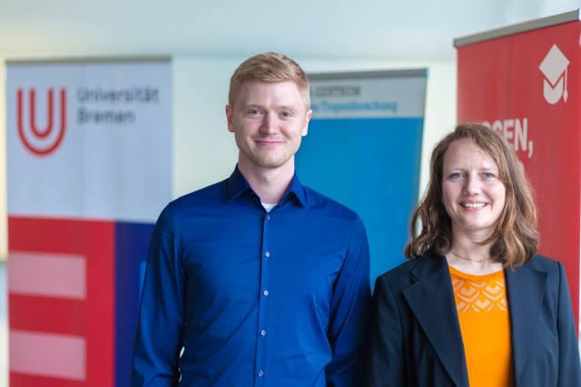
The winners of the CAMPUS PRIZE, Esther Thomsen and Alex Peer Intemann | Photo: Matej Meza, University of Bremen
CAMPUS AWARD Goes to Biologist and Production Technician
The 2023 CAMPUS AWARD: Research for a Sustainable Future winners are biologist Dr. Esther Thomsen from the Leibniz Centre for Tropical Marine Research (ZMT) and master's graduate Alex Peer Intemann from the University of Bremen. The award, endowed with 3,000 euro, was presented at the University on April 27.
In her dissertation, Esther Thomsen investigated the effects of aquaculture effluents on seagrass ecosystems. Seagrass beds grow in shallow coastal seas and cover an area of nearly 18 million hectares worldwide. The data for Esther Thomsen's work was collected over a nine-year period on Hainan Island in China. In doing so, she worked closely with partners on site as well as in Rostock and Hamburg.
Important Seagrass Ecosystem Damaged by Aquaculture Facilities
Due to high nitrogen inputs, aquaculture facilities have a particularly detrimental effect on coastal seagrass beds, which provide important ecological functions. They bind CO₂, provide food and shelter for many species, and are refuges for young animals. Seagrasses filter nitrogen from the water and can thus prevent overfertilization. However, once this ecosystem is damaged, it can no longer fulfill many of these important tasks. The consequences range from loss of biodiversity to CO₂ increases in coastal waters.
For the first time, Esther Thomsen has calculated a threshold value for nitrogen in water, above which a threat to seagrasses is posed. This indicator can be used to prevent the loss of these important ecosystems before the damage is irreversible. The method is not only applicable in Hainan, but also transferable to other regions.
Research Findings Led to Renaturation of the Land
Esther Thomsen presented the results of her investigations to those affected on site. This includes, in particular, fishermen who depend on small-scale and subsistence fishing for their livelihoods and whose food base will be threatened if seagrass beds are destroyed by unrestrained aquaculture operations.
In Hainan, there has also been renaturation of large areas formerly used for aquaculture, as well as replanting of mangroves in said areas. Sea grasses have been reestablished as well. Remaining plants need to be equipped with a wastewater treatment system and made more sustainable, the researcher advises.
The CAMPUS AWARD jury was won over by the fact that this work achieved a concrete result – a threshold value as an indicator for overfertilization – combined with practical consequences. This is exemplary of sustainable research, which is what the award seeks to honor.
Esther Thomsen is currently working on "Project Seagrass" in Scotland. She is pleased with the recognition because it draws what she sees as much needed attention to these often underappreciated underwater plants: "With my work, I hope to help ensure that the problem of eutrophication is not only identified in good time, but also prevented in the future by wastewater treatment systems," she states. "It is only thanks to many years of close cooperation between scientists that it has been possible to determine such a threshold value," explains the researcher and pleads for more long-term studies like her own.
How Wind Turbine Rotor Blades Hold their Own against the Wind
The award-winning master's thesis by Alex Peer Intemann is about a laser-based vibration and deformation measurement of rotor blades on wind turbines.
The rotors are a very sensitive part of wind turbines as they are particularly exposed to the enormous forces of the wind. This applies equally to plants on land and at sea. The constant wind causes deformations which, according to current knowledge, are planned for in the design, but are nevertheless difficult to predict. For the safe operation of a turbine it is important to know the condition of the rotor blades. If damage is detected in time, repair can extend the life of a wind turbine and ensure electricity yields. The information about the nature of the deformation can additionally help to design new rotor blades so that they are less vulnerable, better able to withstand the forces of the wind, and capture its energy more efficiently.
New Method Developed for Inspecting Rotor Blades
Normally, measurements taken from rotor blades of existing turbines are very complex. Alex Peer Intemann has now developed a laser-based method that can be used to determine the condition of a rotor blade very accurately from a distance of over 200 meters from a turbine without interrupting operations. The process was tested with two regional companies on existing wind turbines. The results of his work can be used directly to review the previously used simulations of the turbine behaviour and to achieve an optimization of the rotor blade design, which can save weight and increase the performance of the system. Additionally, operating costs and thus the costs necessary to convert wind into electricity ("electricity production costs") can be reduced. The measurements can also help to keep turbines running longer if no damage is identified.
Practical Contribution to the Necessary Wind Energy Expansion
Alex Peer Intemann's master's thesis in production engineering at the Bremen Institute for Metrology, Automation and Quality Science (BIMAQ) at the University of Bremen has made a practical contribution to the continued urgent need for wind energy expansion. Said urgency is demonstrated not least by the international scientific and entrepreneurial interest of the companies involved. These points also convinced the CAMPUS AWARD jury, who particularly emphasized the concrete applicability of the investigated process.
Alex Peer Intemann thanks BIMAQ for the opportunities made available to him there and says: "The CAMPUS AWARD has showed me that the research I was privileged to contribute to is not only technically interesting, but also points in the right direction in terms of content."
The CAMPUS AWARD
The CAMPUS AWARD honours outstanding theses produced on the campus of the University of Bremen that are thematically dedicated to the sustainable use of resources, the protection of the environment, the climate, and the oceans. The award was established in 2016 and is presented once a year by the KELLNER & STOLL FOUNDATION FOR CLIMATE AND ENVIRONMENT, the Leibniz Centre for Tropical Marine Research (ZMT), the University of Bremen, and the University of Bremen Alumni Network. It is endowed with a total of 3,000 euro.
Further Information:
www.campuspreis.de (in German only)
www.leibniz-zmt.de
www.uni-bremen.de/en/alumni
www.uni-bremen.de/en/
www.stiftung-klima-umwelt.org (in German only)
Contact:
Dr. Rita Kellner-Stoll und Reiner Stoll
KELLNER & STOLL FOUNDATION FOR THE CLIMATE AND ENVIRONMENT
Email: info@campuspreis.de/ info@stiftung-klima-umwelt.org
Phone: +49 421 230569
Andrea Daschner
Leibniz Centre for Tropical Marine Research (ZMT)
Press and Public Relations Office
Phone: +49 421 238 00-72
Email: andrea.daschner@leibniz-zmt.de
Christina Selzer
Administrative Unit - University Communication and Marketing
University of Bremen
Phone: +49 421 218-60158
Email: christina.selzer@uni-bremen.de

Contacts
- PD Dr. Tim Jennerjahn
+49 (0)421 23800 - 44
tim.jennerjahn@leibniz-zmt.de
Details

Working Groups
- WG Ecological Biogeochemistry

